LAB 1: INTRODUCTION (29/01/2021)

EXPERIMENT – 01

**1. Two Python Program:**

a) Write a Python program for Linear Regression.

**Simple Linear Regression**

import numpy as np

import matplotlib.pyplot as plt

def estimate_coef(x, y):

# number of observations/points

n = np.size(x)

# mean of x and y vector

m_x, m_y = np.mean(x), np.mean(y)

# calculating cross-deviation and deviation about x

SS_xy = np.sum(y*x) - n*m_y*m_x

SS_xx = np.sum(x*x) - n*m_x*m_x

# calculating regression coefficients

b_1 = SS_xy / SS_xx

b_0 = m_y - b_1*m_x

return(b_0, b_1)

def plot_regression_line(x, y, b):

# plotting the actual points as scatter plot

plt.scatter(x, y, color = "m",

marker = "o", s = 30)

# predicted response vector

y_pred = b[0] + b[1]*x

# plotting the regression line

plt.plot(x, y_pred, color = "g")

# putting labels

plt.xlabel('x')

plt.ylabel('y')

# function to show plot

plt.show()

def main():

# observations

x = np.array([0, 1, 2, 3, 4, 5, 6, 7, 8, 9])

y = np.array([1, 3, 2, 5, 7, 8, 8, 9, 10, 12])

# estimating coefficients

b = estimate_coef(x, y)

print("Estimated coefficients:\nb_0 = {} \

\nb_1 = {}".format(b[0], b[1]))

# plotting regression line

plot_regression_line(x, y, b)

if __name__ == "__main__":

main()

Output of above piece of code is:

Estimated coefficients:

b_0 = -0.0586206896552

b_1 = 1.45747126437

And graph obtained looks like this:

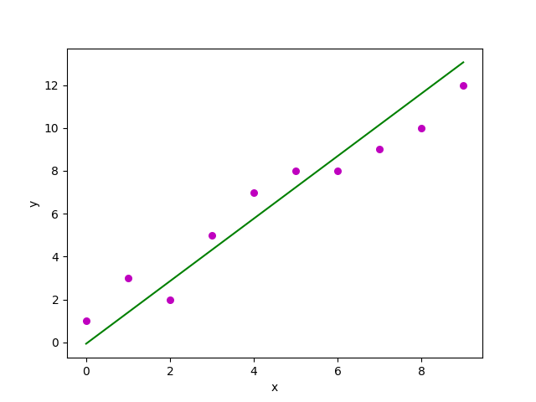

**2. R- Introduction:**

a) Advantages and Disadvantages of R

**Advantages**

1) Open Source

An open-source language is a language on which we can work without any need for a license or a fee. R is an open-source language. We can contribute to the development of R by optimizing our packages, developing new ones, and resolving issues.

2) Platform Independent

R is a platform-independent language or cross-platform programming language which means its code can run on all operating systems. R enables programmers to develop software for several competing platforms by writing a program only once. R can run quite easily on Windows, Linux, and Mac.

3) Machine Learning Operations

R allows us to do various machine learning operations such as classification and regression. For this purpose, R provides various packages and features for developing the artificial neural network. R is used by the best data scientists in the world.

4) Exemplary support for data wrangling

R allows us to perform data wrangling. R provides packages such as dplyr, readr which are capable of transforming messy data into a structured form.

5) Quality plotting and graphing

R simplifies quality plotting and graphing. R libraries such as ggplot2 and plotly advocates for visually appealing and aesthetic graphs which set R apart from other programming languages.

6) The array of packages

R has a rich set of packages. R has over 10,000 packages in the CRAN repository which are constantly growing. R provides packages for data science and machine learning operations.

7) Statistics

R is mainly known as the language of statistics. It is the main reason why R is predominant than other programming languages for the development of statistical tools.

8) Continuously Growing

R is a constantly evolving programming language. Constantly evolving means when something evolves, it changes or develops over time, like our taste in music and clothes, which evolve as we get older. R is a state of the art which provides updates whenever any new feature is added.

**Disadvantages**

1) Data Handling

In R, objects are stored in physical memory. It is in contrast with other programming languages like Python. R utilizes more memory as compared to Python. It requires the entire data in one single place which is in the memory. It is not an ideal option when we deal with Big Data.

2) Basic Security

R lacks basic security. It is an essential part of most programming languages such as Python. Because of this, there are many restrictions with R as it cannot be embedded in a web-application.

3) Complicated Language

R is a very complicated language, and it has a steep learning curve. The people who don't have prior knowledge or programming experience may find it difficult to learn R.

4) Weak Origin

The main disadvantage of R is, it does not have support for dynamic or 3D graphics. The reason behind this is its origin. It shares its origin with a much older programming language "S."

5) Lesser Speed

R programming language is much slower than other programming languages such as MATLAB and Python. In comparison to other programming language, R packages are much slower.

In R, algorithms are spread across different packages. The programmers who have no prior knowledge of packages may find it difficult to implement algorithms.

b) Applications of R

**Applications of R Programming**

1. Finance

2. Banking

3. Healthcare

4. Social Media

5. E-Commerce

6. Manufacturing

**3. R – Installation:**

To Install R:

1. Open an internet browser and go to www.r-project.org.
2. Click the "download R" link in the middle of the page under "Getting Started."
3. Select a CRAN location (a mirror site) and click the corresponding link.
4. Click on the "Download R for Windows" link at the top of the page.
5. Click on the "install R for the first time" link at the top of the page.
6. Click "Download R for Windows" and save the executable file somewhere on your computer. Run the .exe file and follow the installation instructions.
7. Now that R is installed, you need to download and install RStudio.

To Install RStudio

1. Go to www.rstudio.com and click on the "Download RStudio" button.
2. Click on "Download RStudio Desktop."
3. Click on the version recommended for your system, or the latest Windows version, and save the executable file. Run the .exe file and follow the installation instructions.

To Install the SDSFoundations Package

1. Download SDSFoundations to your desktop (make sure it has the ".zip" extension).
2. Open RStudio.
3. Click on the Packages tab in the bottom right window.
4. Click "Install."
5. Select install from "Package Archive File."
6. Select the SDSFoundations package file from your desktop.
7. Click install. You are done! You can now delete the SDSpackage file from your desktop.page.

**4. Some basic commands with output:**

> sqrt(10)

[1] 3.162278

> abs(10)

[1] 10

> ceiling(4.2)

[1] 5

> floor(4.5)

[1] 4

> exp(2)

[1] 7.389056

> pi

[1] 3.141593

> log(100)

[1] 4.60517

> log(100,base=10)

[1] 2

-----------------------------------------------------------------------------------------------